E-AR
AR made Fast and Easy

- Our product
The platform for creating an AR application in 5 simple steps.

- Introduction
Using AR (Augmented Reality) technologies is not new and has received significant exposure these days.
Despite the fact, the use of applications that incorporate this technology is not particularly common in everyday life, and this is because, as of today, AR projects are the result of multidisciplinary work, which includes areas of content, 3D design, software development that integrates AR platforms, and several other fields.
This reality makes AR projects complicated and as result expensive to develop and expensive to maintain.

- Our solution
Our solution is to develop an environment to create an AR application in 5 simple steps that are currently understood by the majority of the population.
All business owners will be able to provide an AR experience in their business without tens or hundreds of developers, designers and so on...
The AR experience will provide an Augmented Reality explanation about business with a character you choose. Like a waitress in a restaurant or a baker in a bakery.
All the above procedures will be done by the user without an expensive team of developers.

- Our target audience
Our target audience consists of several groups:
1. The field of restaurants/pubs/bars.
2. The field of tourism tourist sites, hotels, guest houses.
3. The field of services, health funds, government institutions...
Other words, wherever it is necessary to provide information to the customer.
https://www.statista.com/statistics/897587/world-augmented-reality-market-value/
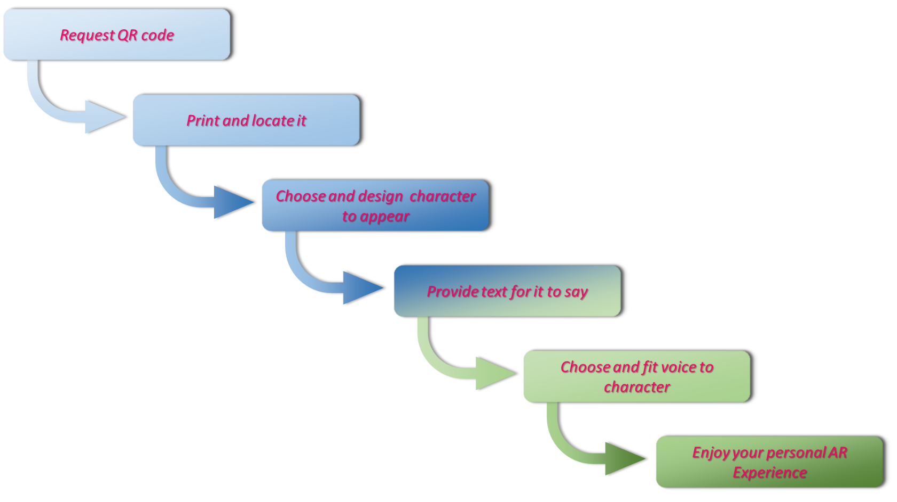
- Only 5 steps to do for your AR experience

- MVP definition
Required functionality is defined by the development of a mobile application, which knows how to fully support the five steps of the application.
For this purpose, a number of additions/extensions must be made to the existing application:
1. Definition, characterization and development of a convenient interface for carrying out the five steps.
- Must creation and combination in the application 4 characters to choose:
2.1. Waitress figure
2.2. Waiter figure
2.3. Receptionist/hostess
2.4. Receptionist/host.
3. Development of an environment for text input, including text2voice capability. Emphasis - making pauses in speech, intonations, facial expressions: smile, seriousness, laughter, etc.
4. Combining the character's movements according to the owner's instructions.
5. Closing the application shell - the whole process from receiving the QR-code to starting the application.

- General architecture
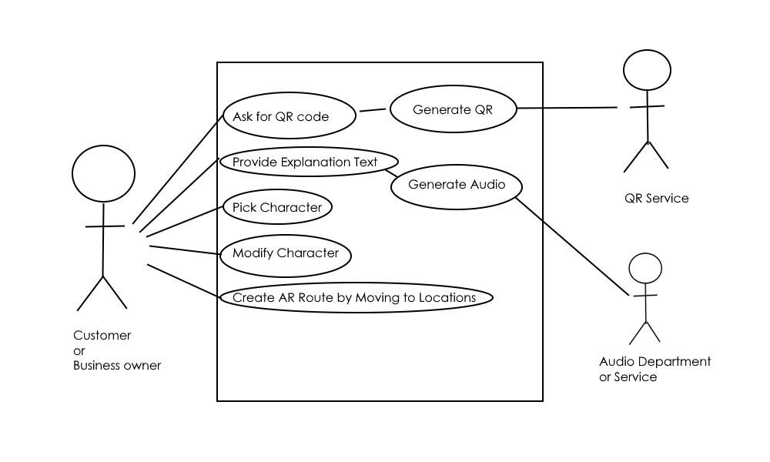

- Future development
Future development will deal with imparting additional functionality and significant expansions of existing capabilities:
- Expanding the number of existing characters.
- Improvement in character selection - ability to choose clothing color, clothing type, hair color.
- Improvement in choosing the voice of the characters - ability to influence the voice in which the text is spoken.
- Creation of AR navigation system just by owner's walking.

